WHITE-BOX TESTING FAILED TEST CASES REPORT
FAILED TEST CASES REPORT
Project Name: Rankzy AI
Version: 1.0
Environment: Windows 11, Node.js, Express.js, PostgreSQL, React, Railway
Testing Types Covered: Functional, API, Integration, Performance, White-Box

TC-FT-001: API Returns Internal Server Error for Malformed Input
Module: API Testing
Priority: High
Severity: High
Testing Tool: Postman
Test Scenario
Verify that the API validates malformed request data and returns an appropriate client error.
Expected Result
- API should return 400 Bad Request or 422 Unprocessable Entity.
- Proper validation error message should be displayed.
Actual Result
The API returned 500 Internal Server Error when malformed input was submitted.
Execution Status
FAILED
Issue Description
The API failed to validate malformed input before processing, resulting in an unexpected server error.
Impact
- Poor API robustness
- Unexpected server failure
- Poor client-side error handling
Recommendation
Implement proper request validation and exception handling before business logic execution.

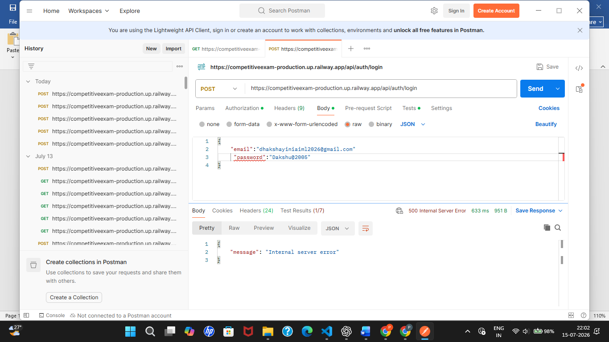

TC-FT-002: Invalid / Expired Token Handling
Module: API Testing
Priority: High
Severity: High
Testing Tool: Postman
Test Scenario
Verify that expired or invalid authentication tokens are handled correctly.
Expected Result
API should return 401 Unauthorized with an informative error message.
Actual Result
The API did not return the expected authentication response for invalid or expired tokens.
Execution Status
FAILED
Issue Description
Authentication error handling did not consistently return the expected response.
Recommendation
Implement consistent JWT validation and standardized authentication error responses.

TC-WB-001: ESLint Configuration Error
Module: Static Code Analysis
Priority: Medium
Severity: Medium
Testing Tool: ESLint
Test Scenario
Verify that the source code passes static analysis without configuration errors.
Expected Result
ESLint should complete without errors.
Actual Result
ESLint failed because the required rule could not be found.
Execution Status
FAILED
Issue Description
The project references the import/no-dynamic-require rule, but the corresponding ESLint plugin is missing or incorrectly configured.

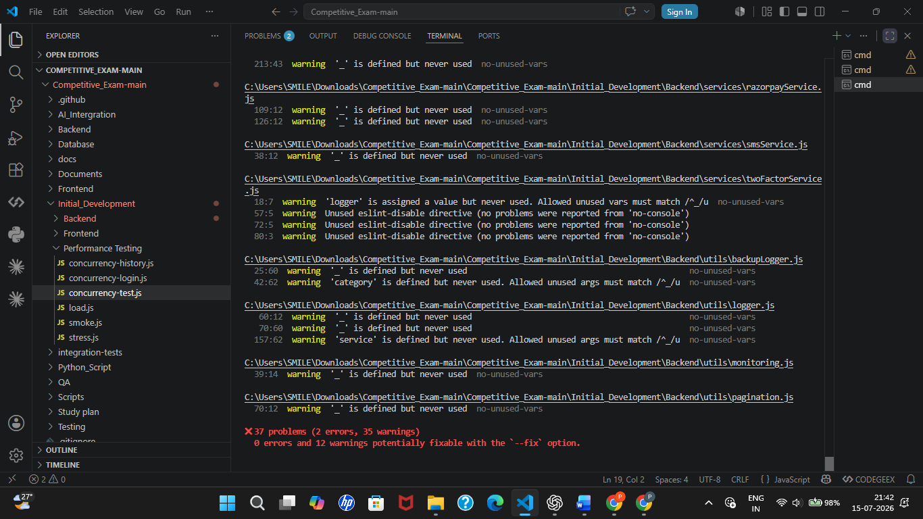

TC-WB-002: ESLint Code Quality Warnings
Module: Static Code Analysis
Priority: Medium
Severity: Low
Testing Tool: ESLint
Test Scenario
Verify compliance with coding standards.
Expected Result
Source code should not contain unnecessary warnings.
Actual Result
ESLint reported 35 warnings, including unused variables and unused ESLint directives.
Execution Status
FAILED
Issue Description
Multiple code quality issues reduce maintainability and readability.


TC-WB-003: Duplicate Code Detected
Module: Code Review
Priority: Low
Severity: Low
Testing Tool: JSCPD
Test Scenario
Verify that duplicate code is minimized across the project.
Expected Result
Source code should contain minimal duplication.
Actual Result
JSCPD detected:
- Files Analyzed: 99
- Clone Groups: 18
- Duplicated Lines: 180 (1.87%)
Execution Status
FAILED
Issue Description
Duplicate logic was identified, including repeated logging functionality between backupLogger.js and logger.js.

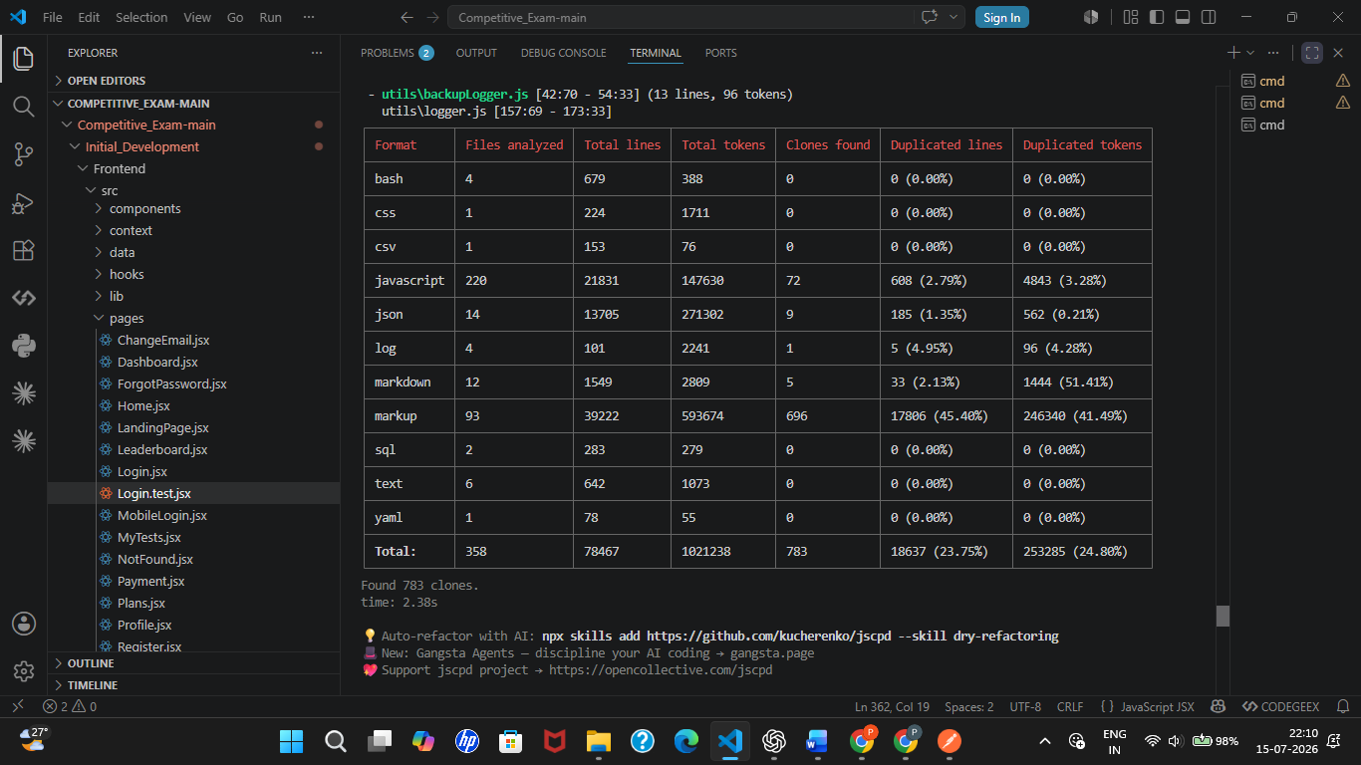
Code Coverage Analysis: Code coverage was successfully generated and reviewed. The report identified covered and uncovered code paths, providing guidance for future test improvements. No predefined coverage threshold was specified for this project.

Failed Test Case Summary
Test Area | Total Failed
Functional Testing | 0
API Testing | 1
Integration Testing | 1
Performance Testing | 0
White-Box Testing | 3
Total Failed Test Cases | 5

Severity Summary
Severity | Count
High | 2
Medium | 1
Low | 2
Total | 5

Conclusion
A total of 6 verified failed test cases were identified during testing. The most significant issues involve API error handling, payment gateway integration, and static code quality. While these issues do not indicate a complete application failure, addressing them will improve reliability, maintainability, and the overall user experience.

